Item 3 - Minutes of the Meeting of the

Friday 11th December 2020
North West Region Waste Management Group Joint Committee
Friday 11th November 2020 @ 12.15 PM
Webex Call

Present: - Alderman Bresland (vice-chair), Councillor Mooney, Councillor McCann, Councillor Nicholl and Councillor Burke.

In Attendance: - Clerk to the Committee (Mr E. Molloy), NWRWMG (Mr K. Swerdlick, Miss J. Curran).

Notice and Summons of Meeting

The Clerk read the Notice and Summons for the Meeting.

Apologies

Apologies were received from Councillor Wallace, Councillor McQuillan and Karen Phillips.

Item 1 – Declaration of Members’ Interests

There were no declarations of Members’ interests.

Item 2 - Report to those Charged with Governance NIAO (Draft)

The Clerk referred to the attached report to those charged with governance.

The Clerk informed members that the Audit & Risk committee received this report at its meeting earlier today and he proceeded to take members through the report.

The Clerk also drew member’s attention to the Audit Findings. He informed members that there were no recommendations from the auditor and that the audit opinion is unqualified.

Councillor Nicholl stated that from the Audit & Risk committee perspective it was very pleasing to see an unqualified report.

This was PROPOSED by Councillor Nicholl and SECONDED by Councillor Mooney.

Members agreed the report.

Item 3 - Presentation of the Financial Statements 2019-2020 of the NWRWMG Joint Committee

The Clerk stated that the accounts have been prepared in line with the code of practice and the financial statement explain the Joint Committee finances during the financial year up to the 31st March 2020.

The Clerk took members through the accounts explaining and highlighting key changes with the previous year’s accounts and took questions and comments from members.

Members thanked the Clerk for the comprehensive presentation of the accounts and they were PROPOSED by Councillor Nicholl and SECONDED by Councillor Mooney.

Members unanimously approved the accounts.

Members agreed that the accounts should be signed and submitted as directed.

Item 4 - Any Other Relevant Business

The next meeting of the Joint Committee will take place on Wednesday 20th January 2021. This was PROPOSED by Councillor Mooney and SECONDED by Councillor McCann.

There being no other relevant business the Chair wished everyone a Happy Christmas and a peaceful New Year. The Chair thanked everyone for their attendance and closed the meeting.

The meeting terminated at 12.35pm

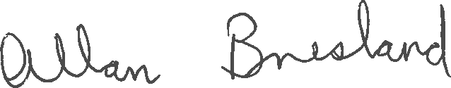
Signed: _____________________________
Alderman Bresland
Vice-Chair

